By the close of Term 1, the project aims to have produced a reviewed and explainable artificial innovation network with a small, well-defined parameter set (≈ 1–5 free parameters). The model should reliably generate directed acyclic graphs* exhibiting innovation-like citation structure and allow for reproducible statistics over multiple runs. From this foundation, two (sort of) logically distinct yet complementary directions follow.
i) Exploration of whether main-path and/or critical-path algorithms applied within our artificial network generate meaningful, interpretable** .
ii) Comparison of the artificial system with a real, empirical innovation network, establishing statistical comparability so that “meaningful” refers to empirical validity rather than internal coherence alone.
Given that most path-finding literature (e.g. Liu et al. 2019; Ho et al. 2024) develops its metrics on empirical networks, this second task may, in practice, precede or inform the first. Therefore, the idealised end-point remains to demonstrate i) via using information obtained from successful ii).
*or I suppose essentially d.a.g. graphs we then clean using the same cleaning methods as applied in literature for a fair comparison (just an idea if time permits at end, then maybe actual d.a.g.s too and then we can study the cleaning process?)
**Defining meaningful interpretable is harder than I would have thought without ii). I guess loosely perhaps “meaningful” would imply some kind of internally consistent identification of dominant causal trajectories
Week 1 (Term 2): Consolidation and Assessment
- Overflow
W2T2: Figures required & story of report assessment; find out what needs to done
- Outline the narrative arc of the report and begin to structure the report. What is the end point and conclusion? What are the money figures?
- List all figures/analyses crucial to the to support the end point who’s logic is not yet in place and plan implementation.
W4T2: new model vs new network point pass results
- Implement i/ii) analysis in whatever form that ends up being in
Suggestions:
- Run systematic comparisons between artificial network and real data
- Focus on a few key metrics rather than everything possible
- Document what works and what doesn't
W5T2: address holes in report e.g. what's a marker going to feel, where's the fake physics that I've b*llshitted
Suggestions:
- Be honest about model limitations
- Explain clearly what’s being measured and why it matters
- Make sure every claim is either supported by results or acknowledged as speculative
W6T2: Ruddow, Tidy up bullshit, try not to develop any new ideas
Suggestions:
- Focus on clarity and completeness
- Polish existing work rather than starting new threads
W7T2: Slow structure demand review & isolate honey figures made sure the many plots we oral
Suggestions:
- Focus on figures
- Remove anything that doesn't contribute to argument
- Make sure figures have clear labels and captions
W8T2: Plan report with all in place & review extremely w Tim
Suggestions:
- Full draft outline with all sections planned
- Kind of interesting point we probably wont fully address either but would be nice to have some literature on and some form of brief address albeit caveating this isn’t a sociology paper and further work will be needed:
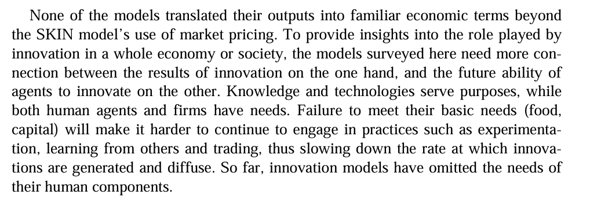
- Best to acknowledge but were not working with economists (maybe footnote/ single sienstence in discussion)
- Share with Tim early enough to incorporate feedback
- Identify which sections need most work
W9T2: Write report w feedback
W10T2: Write report w feedback
W11T2: (Write report w feedback
W12T2:
- Final polish and proofreading
- Check all references are complete
- Ensure all figures are referenced in text

